**Alejandro Casillas**

**Rhys Phelps**

**ECNS 460**

**October 10th, 2023**

**Stage 1: Topic and Data**

**Research Question:** Which of the industry sectors in the U.S. were impacted most due to the transition of NAFTA to USMCA?

**Approach & Motivation:**

To address this question, we'll delve into foreign trade data, focusing on the volume and value of goods traded between US-MEX and US-CAN before and after the transition. By comparing sectoral trade data from the NAFTA era to the USMCA era, we can discern which sectors saw increased trade, which saw decreases, and which remained relatively unaffected. Our research question and topic of interest is important because the benefits and impacts of these trade programs take years to develop and by analyzing how the industry sectors were affected in the course of NAFTA we'll be able gauge the real changes and impacts caused by enacting USMCA.

**Data Requirements:**

**1. Trade Data under NAFTA:**

- Detailed trade data segmented by industry or sector for the US, Canada, and Mexico during the NAFTA years.

**2. Trade Data under USMCA:**

- Similar detailed trade data, but for the period after the USMCA came into effect.

**3. Macroeconomic Indicators:**

- GDP growth, inflation rates, and unemployment data from the US, Canada, and Mexico for the same period to control for broader economic influences. As well as tariffs, quotas, and trade barriers.

**Datasets:**

**1. Tariff rates for U.S. agricultural trade with Canada and Mexico: NAFTA, MFN, and WTO-bound:**

This dataset provides tariff estimates based on trade-weighted averages from three distinct tariff rate sets: NAFTA, Most Favored Nation (MFN), and World Trade Organization bound tariff rates (WTO). It comprises 11 variables. Eight of these variables offer tariff estimates for exports and imports between the US and Mexico (US-MEX) and the US and Canada (US-CAN) using NAFTA and MFN rates. The remaining three columns focus on WTO bound rates for Canada, Mexico, and the US.

Currently, the rows represent various subsectors within the Agricultural sector. After transposing the dataset, these subsectors will be the variables. The reference indicates that this dataset builds upon calculations from prior works spanning 2014-2016. This dataset can be described as follows:

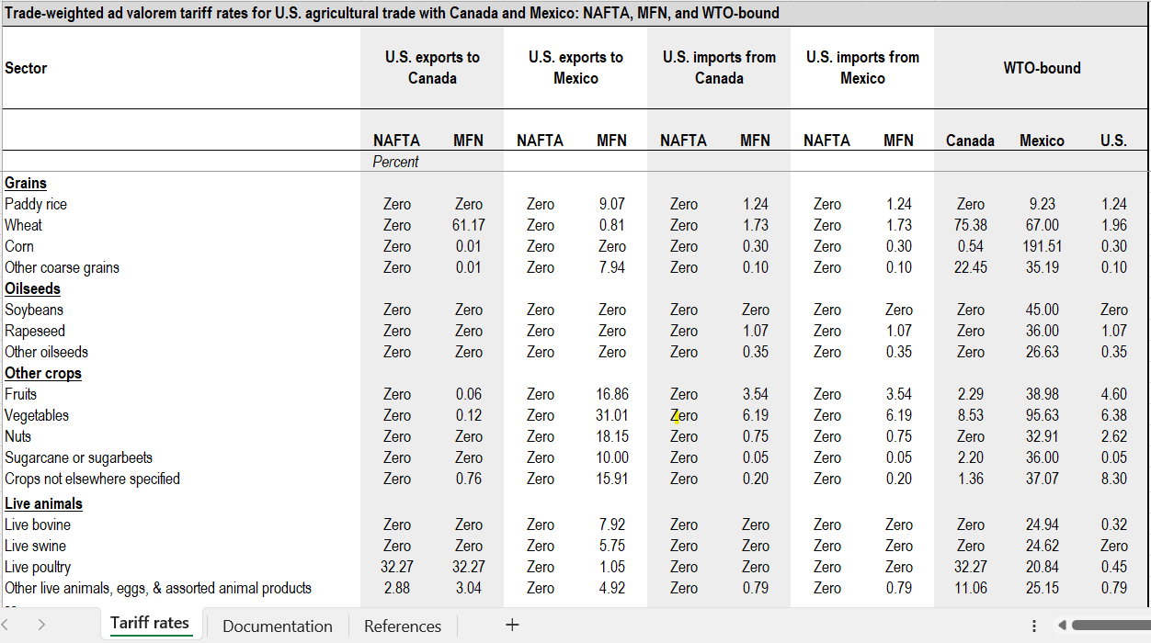

<https://www.ers.usda.gov/topics/international-markets-u-s-trade/countries-regions/usmca-canada-mexico/data/>

**2. US exports by sector and digest, 2015-2019:**

This dataset complements the initial dataset by providing a cross-sectional view of the total export values categorized by digest. It covers exports and imports between the US, Mexico, and Canada across all industry sectors. While datasets for exports and imports will be merged, they will remain distinct. For clarity in analysis, the dataset should be transposed: current observations or rows, representing different export digests, should become columns or variables. The time frame for these observations spans from 2015 to 2019.

It's essential to understand that this dataset's utility lies in its insights on NAFTA; it does not provide perspectives on USMCA post-2019. Both datasets are intertwined by their industry-sector columns. However, the former focuses exclusively on the Agricultural sector. The first dataset is analogous to another that encompasses all industry sectors and details partner balances/volumes.

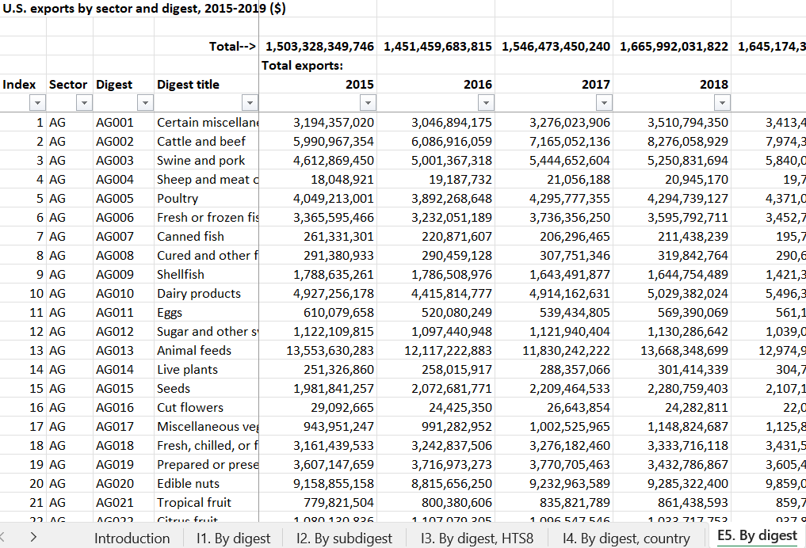

<https://www.usitc.gov/research_and_analysis/trade_shifts_2019/us.htm>

**Analysis Plan:**

**1. Descriptive Analysis:** Compare the trade volumes and values of each sector under NAFTA and USMCA. Identify sectors with significant increases or decreases in trade.

**2. Causal Analysis:** Employ a Difference-in-Differences (DiD) methodology to ascertain if there's a causal link between USMCA's advent and any trade fluctuations in specific sectors.

**3. Economic Indicators Correlation:** Determine if any observed changes in trade patterns align with shifts in the broader economic indicators, ensuring that the effects we attribute to the USMCA aren't just reflections of broader economic trends.

**Expected Deliverables:**

* A curated list pinpointing sectors that experienced substantial trade alterations following the introduction of USMCA.
* A comprehensive report that deciphers the underpinning reasons behind these changes.
* Strategic recommendations catered to sectors that display promising potential or demand a reevaluation under the USMCA umbrella.

**Anticipated Outcomes:**

Upon concluding the analysis, we should discern which sectors or industries experienced the most significant shifts due to the transition from NAFTA to USMCA. We'll aim to provide insights into the driving forces behind these shifts and the implications for future trade dynamics among the three nations.

https://github.com/acasillas1407/ECNS-460-Project.git